Homework 3 Report

CSC 4320 Operating Systems

Spring 2018

Name: Jimmy Tran

Email: [jtran25@student.gsu.edu](mailto:jtran25@student.gsu.edu)

As a side note regarding my program, I intentionally delayed when the producer and consumer threads started in order to avoid attempts to consume before producing and to avoid getting too much output at once.

1) Source Code

#include <stdio.h>

#include <stdlib.h>

#include <pthread.h>

#include <semaphore.h>

#define TRUE 1

typedef int buffer_item;

#define BUFFER_SIZE 8

buffer_item START_NUMBER;

int insert_item(buffer_item item);

int remove_item(buffer_item *item);

buffer_item buffer[BUFFER_SIZE];

pthread_mutex_t mutex;

sem_t empty;

sem_t full;

int insertPointer = 0, removePointer = 0;

void *producer(void *param);

void *consumer(void *param);

int insert_item(buffer_item item)

{

/* Implementation of the insert_item() function */

if(insertPointer>=BUFFER_SIZE) //return to beginning of buffer

insertPointer=0;

if(insertPointer<BUFFER_SIZE){

buffer[insertPointer]=item;

insertPointer++;

}

else

return -1;

return 0;

}

int remove_item(buffer_item *item)

{

/* Implementation of the remove_item function */

if(removePointer>=BUFFER_SIZE) //return to beginning of buffer

removePointer=0;

if(removePointer>=0&&removePointer<BUFFER_SIZE){

*item = buffer[removePointer];

removePointer++;

}

else

return -1;

return 0;

}

int main(int argc, char *argv[])

{

/* 1. Get command line arguments argv[1],argv[2],argv[3],argv[4] */

/* 2. Initialize buffer */

/* 3. Create producer thread(s) */

/* 4. Create consumer thread(s) */

/* 5. Sleep */

/* 6. Exit */

int sleepTime, producerThreads, consumerThreads;

int i, j;

if(argc != 5)

{

fprintf(stderr, "Usage: <sleep time> <producer threads> <consumer threads> <start number>\n");

return -1;

}

sleepTime = atoi(argv[1]);

producerThreads = atoi(argv[2]);

consumerThreads = atoi(argv[3]);

START_NUMBER = atoi(argv[4]);

/* Initialize the synchronization tools */

sem_init(&full, 0, 0);

sem_init(&empty, 0, BUFFER_SIZE);

pthread_mutex_init(&mutex, NULL);

/* Create the producer and consumer threads */

pthread_t pro, con;

for(int i=0; i<producerThreads;i++){

pthread_create(&pro, NULL, producer, START_NUMBER); //create producers

}

for(int j=0; j<consumerThreads;j++){

pthread_create(&con, NULL, consumer, NULL); //create consumers

}

/* Sleep for user specified time */

sleep(sleepTime);

return 0;

}

void *producer(void *param)

{

/* Implementation of the producer thread -- refer to Figure 5.26 on page 256 */

buffer_item item;

while(TRUE){

sleep(1);

item=START_NUMBER;

sem_wait(&empty); //lock empty semaphore if !0

pthread_mutex_lock(&mutex); //mutex lock

if(insert_item(item)){

fprintf(stderr, "Insert into buffer failed\n");

}

else{

printf("Producer %u produced %d \n",(unsigned int)pthread_self(), item);

START_NUMBER++;

}

pthread_mutex_unlock(&mutex); //mutex unlock

sem_post(&full); //increment full semaphore

}

}

void *consumer(void *param)

{

/* Implementation of the consumer thread -- refer to Figure 5.26 on page 256 */

buffer_item item;

while(TRUE){

sleep(2);

sem_wait(&full); //lock full semaphore

pthread_mutex_lock(&mutex); //mutex lock

if(remove_item(&item)){

fprintf(stderr, "Removal from buffer failed\n");

}

else

printf("Consumer %u consumed %d \n",(unsigned int)pthread_self(), item);

pthread_mutex_unlock(&mutex); //mutex unlock

sem_post(&empty); //increments empty semaphore

}

}

2) Screenshots:

Scenario 1: More Producers than Consumers

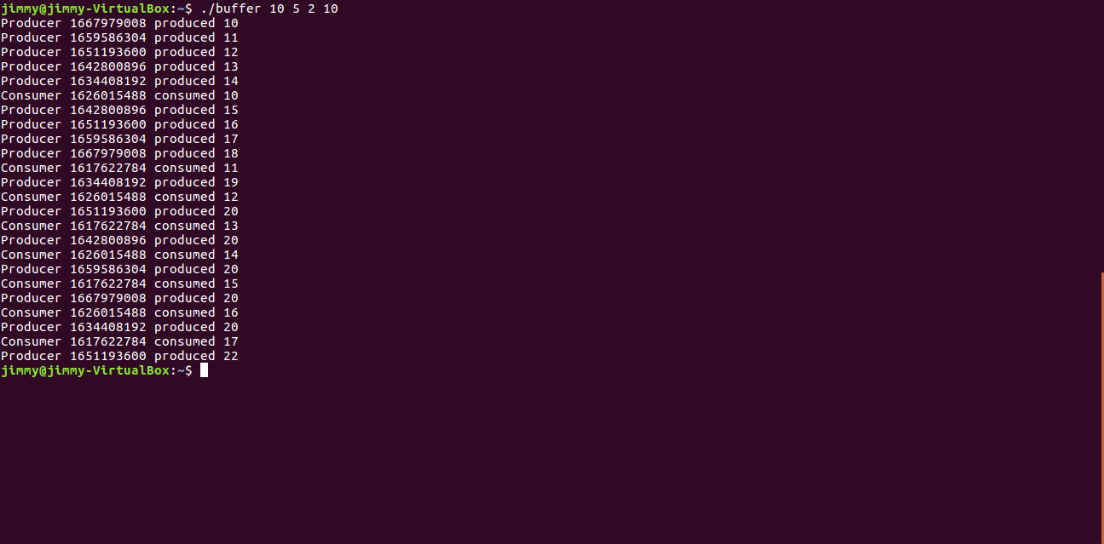

Scenario 2: More Consumer than Producers

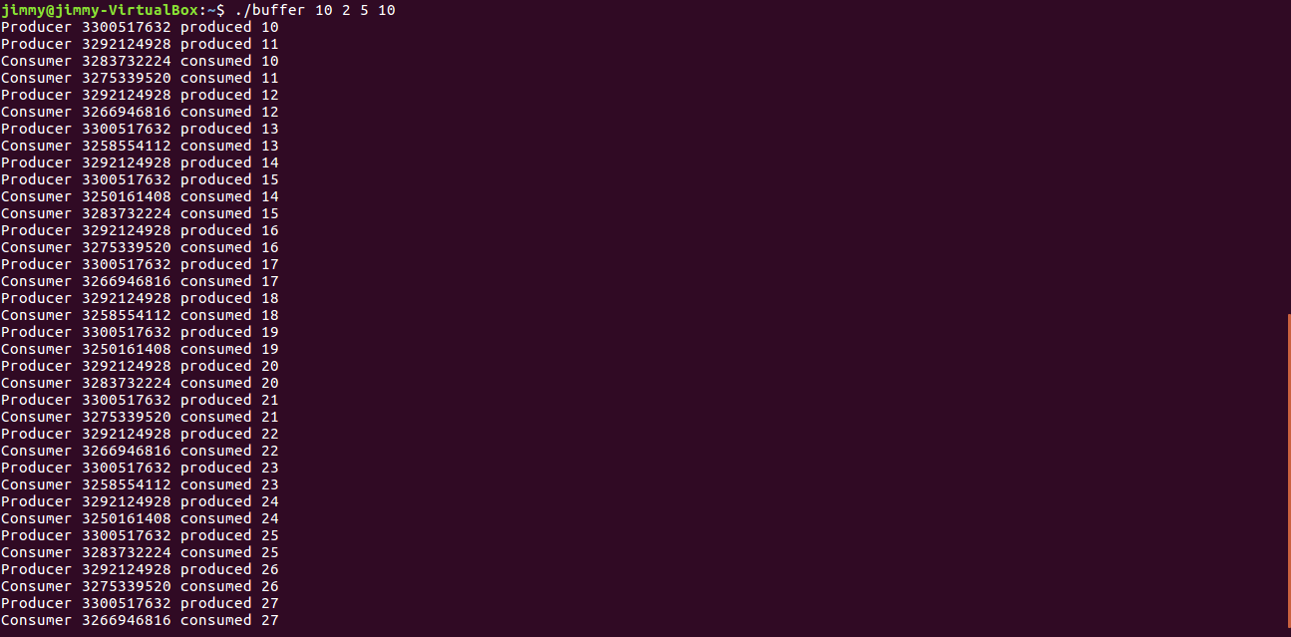

Scenario 3: Equal number of Consumers and Producers

